Submitted By: Hamza Mehboob
NIAI
LAB SETUP GUIDE

Guide for VMware Workstation Pro

This is a step-by-step basic guide for setting up a virtual environment. A virtual environment is necessary yet a simple, real-time sandbox for network and simulation. This helps the pen tester to analyze and monitor any vulnerabilities in a controlled environment and provides useful experience for real life scenarios.

VMware Workstation Pro:
VMware Workstation Pro is a tool that allows multiple virtual machines to run on your system, eliminating any need for multiple computers.

Go to the official site VMware.com

VMware Workstation Pro is available on their official site. Navigate to the download page and click the “Download Now” button.

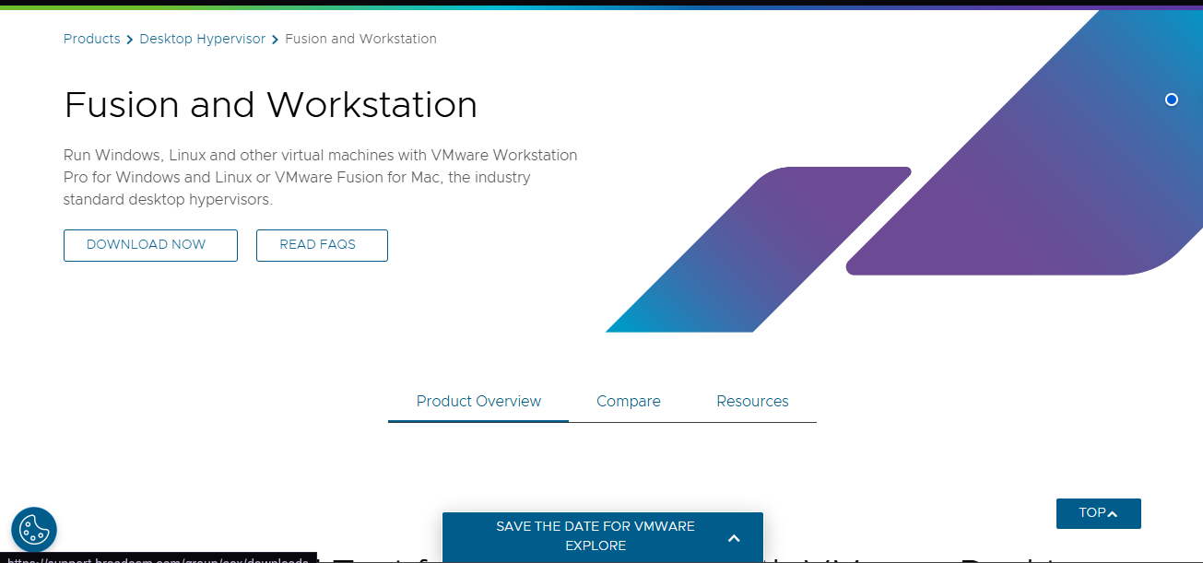

- Downloading will redirect you to the Broadcom website. Create an account there.

Look for the Register option in upper right corner and click it.
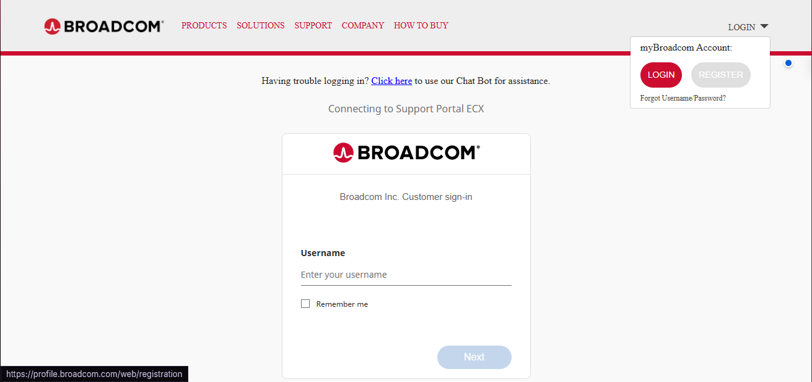

Fill in the details in the registration form.
Complete the process by adding all registration details. Complete the process by checking off the Terms & Conditions option and hit “Create Account”.

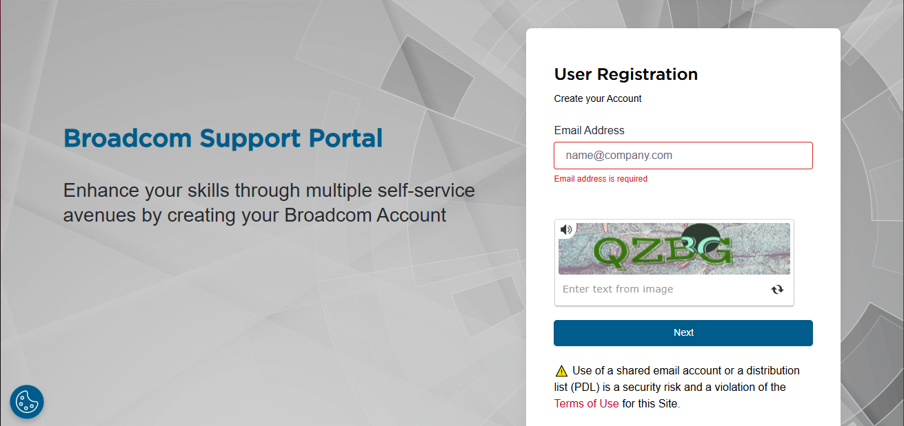

- After registration, navigate to the “My Downloads” page from Dashboard.
After clicking My Downloads button, click ALL Products button and search for VMware Workstation Pro and download the latest version.
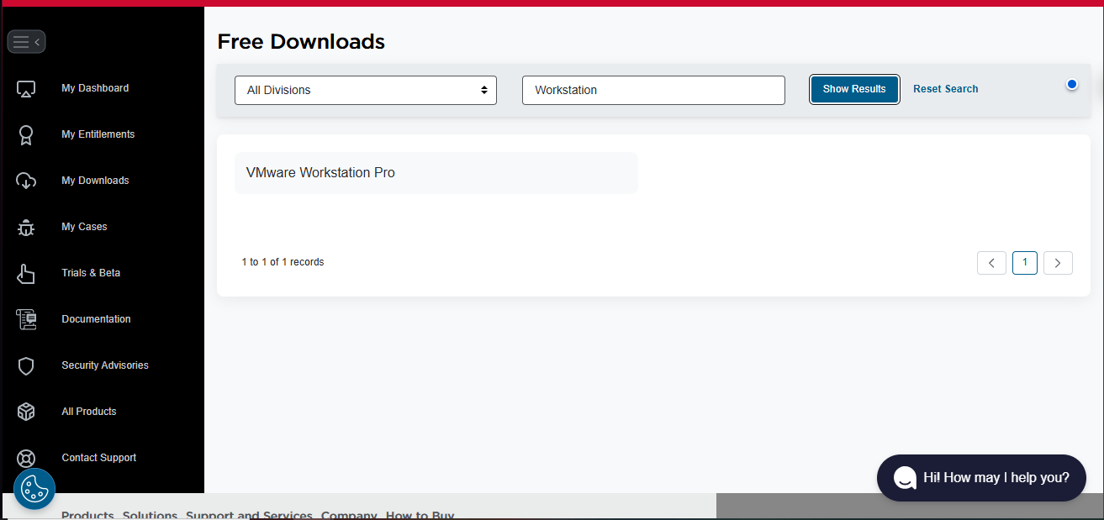

- After its downloaded, navigate to downloads folder and open the installer
Once opened, follow the instructions on VMware Workstation Pro wizard and click Next.

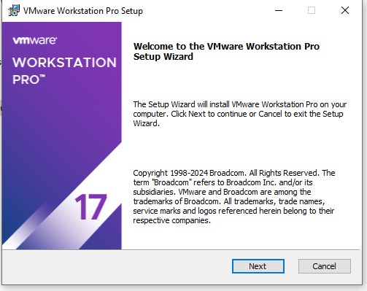
- Accept Terms & Conditions and continue the process.
Accepting the Terms & Conditions of usage of VMware Workstation Pro is necessary, read carefully and proceed.

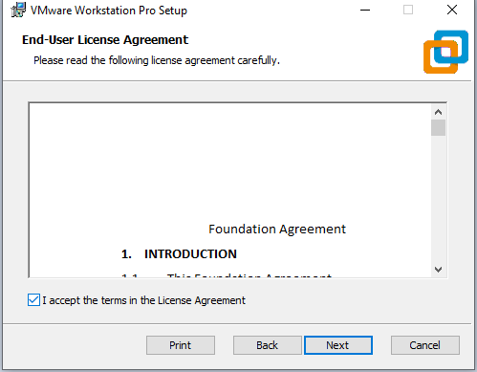

- Select the installation location for VMware by clicking the ‘Change’ button.
Let it remain unchanged if you prefer the default location and click Next.

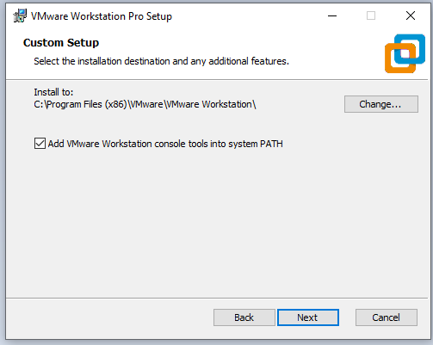
- Customize your VMware User experience and click the ‘Next’ button.
It's recommended to select “Check for Product Updates” as it keeps VMware up to date with the current version. You can join the improvement program if you prefer. Once done, click “Next”

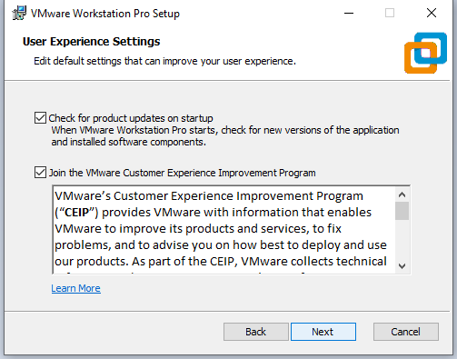
- Select your shortcut locations and continue.
Choose Desktop and Start Menu options or both if you prefer and hit Next.

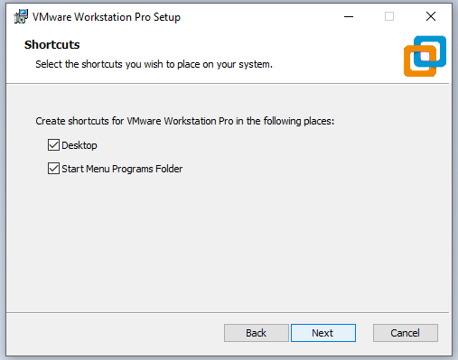
- At this point, you’re set to go. Once you’re ready, hit “Install” button
If you’ve missed anything, you can easily go back at this point. Click the “Install” button to begin the final phase.

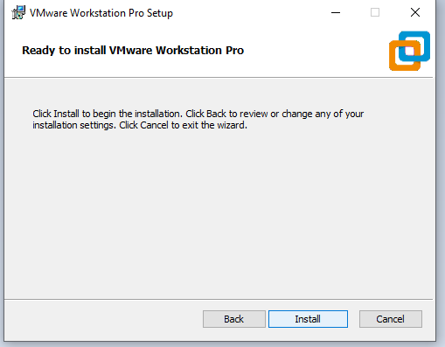

Once the wizard setup is completed, VMware Workstation Pro is successfully installed on your system.

